**INFM600:**

**PROJECT SUMMARY**

**Shashank Kava**

**Sohan Shah**

**Alexandra Steinheimer**

TORNADOES vs AGRICULTURAL EXPORTS

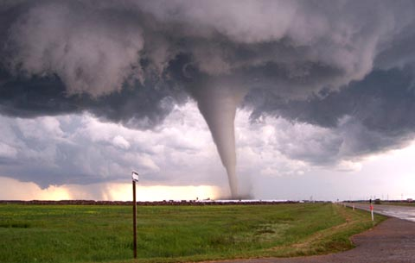

**TARGET AUDIENCE**

The United States Department of Agriculture (USDA) would benefit the most from our analysis. USDA is a federal department responsible for laws related to farming, agriculture and food. They promote agricultural trade and production in the United States and also internationally.

**IMPACT**

Our project works as a regression model which USDA can use to determine the effect of tornadoes on agricultural exports, plant and animal products. They can use weather forecasting data from the National Weather Service agency and, with the help of our model, determine its impact on agricultural exports. Having this information beforehand also gives them the opportunity to take measures and minimize the economic damage.

**SOURCE DATA AND PROCESSING**

We integrated two data sources: a data set of all tornadoes in the United States since 1950 (<http://www.spc.noaa.gov/wcm/#jmc>) and agricultural/crop export data from USDA (<http://www.ers.usda.gov/data-products/state-export-data.aspx>). The tornado data comes from the National Weather Service. It includes information on tornado incidence, F-scale, and the states a tornado passed through. The agricultural export data set breaks down the agricultural exports of each state, as well as the revenue generated per export.

We processed the data through Microsoft Excel and R. To efficiently address our research questions, we aligned each state with its appropriate region, removed irrelevant data, and merged the two different data sets we had. Through a combination of excel pivot tables and the subset( ) function in R, we targeted only the tuples that would answer our research question.

**CONCLUSION**

Results of the regression test shows that Texas has seen the maximum number of tornadoes over the years, and there is a significant relationship between tornado incidence and agricultural exports. Our model states that when the tornado count increases by a factor of 1 in Texas, the revenue generated through agricultural exports reduces by a little over $23 million. No significant relationship was seen in any other state, which could imply that the relationship is only above a certain threshold value of tornado count, or there is a third variable factor in play.